|  |  |  |  |  |
| --- | --- | --- | --- | --- |
| **Sl. No.** | **Practical Out Comes/Practical exercises** | **Unit**  **No.** | **PO** | **CO** |
| 1 | Write an algorithm for programmable problems Example for Reference:   * Add/subtract two numbers * Find the largest/smallest of 3 numbers * Calculate and print sum of 'N' numbers | 1 | 1,4,7 | 1 |
| 2 | Design a flowchart for programmable problems Example for Reference:  Add/subtract two numbers  Find the largest/smallest of 3 numbers Calculate and print sum of 'N' numbers | 1 | 1,4,7 | 1 |
| 3 | Design and create simple game using MIT-scratch/Code.org | 1 | 1,4,7 | 1 |
| 4 | Design and create simple android application (MIT App Inventor) | 1 | 1,4,7 | 1 |
| 5 | Design and create webpage for displaying your poem (Title,  header, paragraph, formatting tags) | 2 | 1,4,7 | 2 |
| 6 | Design and create webpage for your wish list (What you want to do). Also list challenges and opportunities along with images to  present your dreams (List ordered and unordered, Image, table) | 2 | 1,4,7 | 2 |
| 7 | Design and create webpage using HTML and CSS about an  awesome animal (Use necessary CSS tags) | 2 | 1,4,7 | 2 |
| 8 | Design and create web page for a travel book/recipe book with  more than 3 pages, table to list places/recipes (iframe, hyperlink) | 2 | 1,47 | 2 |
| 9 | Design and create web page with JavaScript to design a simple  calculator to perform the following operations: sum, product, difference and quotient | 2 | 1,4,7 | 2 |
| 10 | Design and create a personal webpage with dashboard | 2 | 1,4,7 | 2 |
| 11 | Design and create web page about advantages of business process  automation with respect to your branch of engineering | 2,3 | 1,4,7 | 2,3 |
| 12 | Create a workflow for education loan approval in bank/diploma  admission process (Use any tool) | 3 | 1,4,7 | 3 |
| 13 | Demonstrate ERP with ERPNext Demo for manufacturing, retail  and service sector (Use any other ERP tools) | 3 | 1,4,7 | 3 |
| 14 | Create user account and demonstrate use of Google drive, Google docs, Google Co-lab (Usage of Jupyter Notebook) | 4 | 1,4,7 | 4 |
| 15 | 1.1 Demonstrate Internet of Things using with examples   1. Smart home 2. Smart city 3. Smart farming   Note: Teacher can also select specific area of work where Things  (autonomous computing devices) could be interconnected over TCP/IP to establish IoT. | 4 | 1,4,7 | 4 |
| 16 | Installation of Antivirus software | 5 | 1,4,7 | 5 |
| 17 | Demonstration and hands on browser settings | 5 | 1,4,7 | 5 |
| 18 | Demonstration and hands on privacy settings and password policy | 5 | 1,4,7 | 5 |
| 19 | Demonstration of common security threats (using videos)   1. Phishing 2. DoS attack 3. Man in the middle attack 4. Spamming 5. Virus | 5 | 1,4,7 | 5 |

**Program 1**

1. **Write an algorithm to Add two numbers**

Step 1: Start

Step 2: Input a,b

Step 3: compute sum=a+b

Step 4: print sum

Step 5: End

1. **Write an algorithm to subtract and multiply two numbers**

Step 1: Start

Step 2: Input a,b

Step 3: compute diff=a-b

Step 4: compute prod=a \* b

Step 5: print diff

Step 6: print prod

Step 7: End

1. **Write an algorithm to print bigger of 2 numbers**

Step 1: Start

Step 2: Input a,b

Step 3: if a > b

print a

else

print b

Step 4: End

**d)Write an algorithm to find the largest of 3 numbers**

Step 1: Start

Step 2: Input a,b,c

Step 3: if (a > b and a>c)

print a is largest number

else if (b >a and b>c)

print b is largest number

else

print c is largest number

Step 4: End

**e)Write an algorithm to find the smallest of 3 numbers**

Step 1: Start

Step 2: Input a,b,c

Step 3: if (a < b and a<c)

print a is smallest number

else if (b<a and b<c)

print b is smallest number

else

print c is smallest number

Step 4: End

**f)Write an algorithm to Calculate and print sum of 'N' numbers**

Step 1: start

Step 2: assign sum=0, i=0

Step 3: Input N

Step 4: repeat step5 to 6 until i=n

Step 5: compute sum=sum+i

Step 6: compute i=i+1

Step 7 print sum

Step 8: end

**Program 2**

1. **Draw a flowchart to Add two numbers**
2. **Draw a flowchart to subtract and multiply two numbers**
3. **Draw a flowchart to print bigger of 2 numbers**

**d) Draw a flowchart to find the largest of 3 numbers**

**e) Draw a flowchart to find the smallest of 3 numbers**

**f) Draw a flowchart to Calculate and print sum of 'N' numbers**

**Program 3**

1. **Design and create a simple clicker game using MIT-scratch**

**Sprite** – Pictures available in scratch

**Blocks** – we can give commands to sprites and those commands are called as blocks

**Program or script** – in the middle of the screen is a blank area. You can put together blocks here to make commands. This is called a script.

Step 1 : Open scratch software and select new project

Step 2 : Select a new sprite - balloon

Step 3 : Select 4 backdrops

Step 4 : Make a variable named “score”- The score increases by 1 when balloon is clicked

Step 5 : Create the following code blocks for the balloon sprite

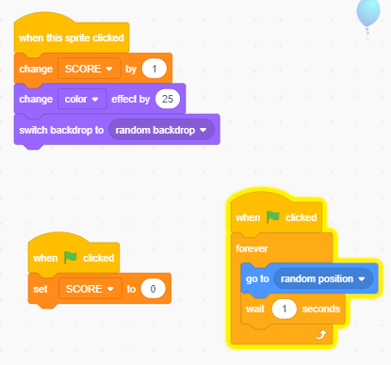

**OUTPUT**

**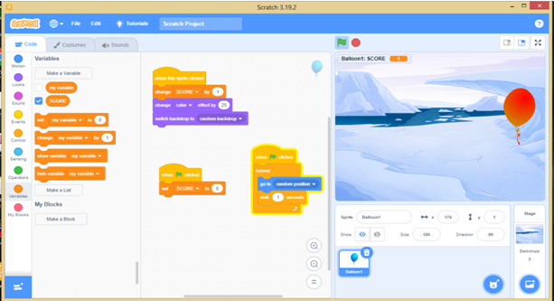**

**4 Design and create simple android application (MIT App Inventor)**

Step 1 : In Google search for MIT App Inventor and open it.

Step 2 : Click the create button

Step 3 : Login with your Gmail account and click continue

Step 4 : Click on start new project and give a project name.

Step 5 : In design view Select Horizontal Arrangement 1 from Layout

- Set the height and width property

- Set image property to bulb OFF image

- Disable visible property

Step 6 : Select Horizontal Arrangement 2 from Layout. In property window set following properties

- Set the height and width property

- Set image property to bulb ON image

- Disable visible property

Step 7 : Select Button 1 from user interface. In property window set following properties

* Set the width
* Set height
* Rename as ON

Step 8 : Select Button 1 from user interface. In property window set following properties

* Set the width
* Set height
* Rename as OFF

Step 9 : Drag and drop following blocks in code window

Step 10: Run the application

-install MIT A12 companion from playstore on your mobile.

**-** Scan QR code

-Open app in the web site

**OR**

**-** Start AI Starter

**-** click onConnect - Emulator

**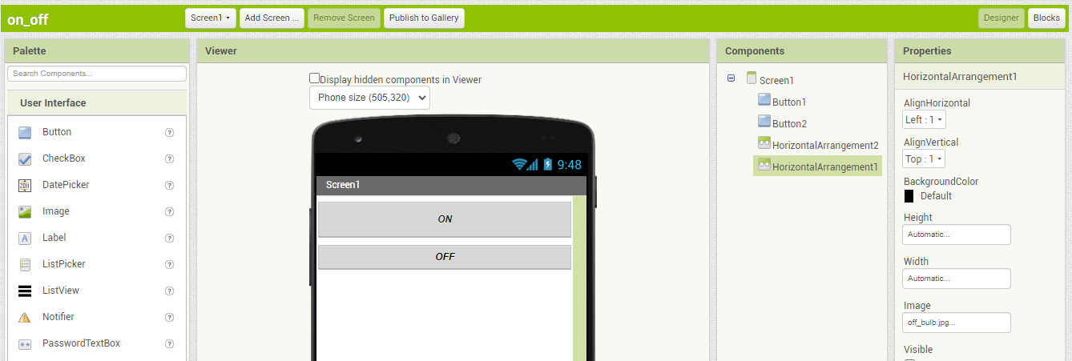**

**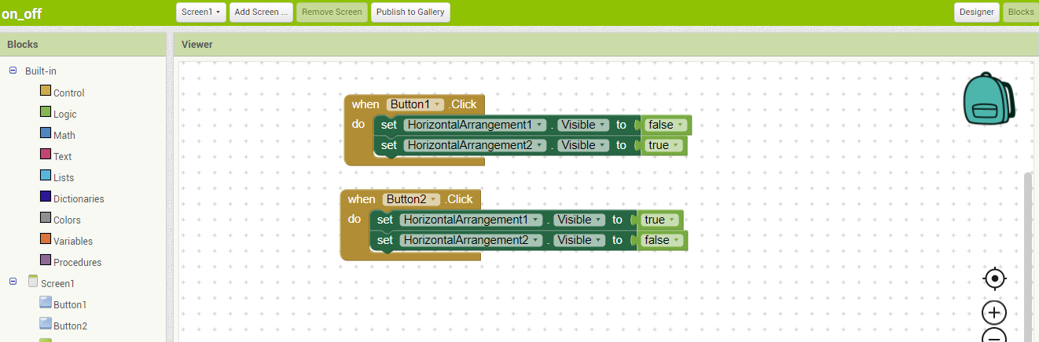**

**OUTPUT:**

**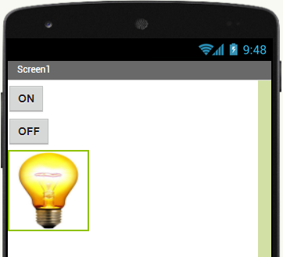**

**Ex 5. Design and create webpage for displaying your poem**

<!DOCTYPE html>

<html>

<head>

<title>My Poem </title>

</head>

<body><center>

<h1>Rhymes</h1>

<img src="twinkleimg.jpg" width="300" height="200">

<p><font color="red">

Twinkle, twinkle, little star, <br>

<b><i> how I wonder what you are!</b></i><br>

Up above the world so high, <br>

Like a diamond in the sky!

</p>

</body>

</html>

OUTPUT:-

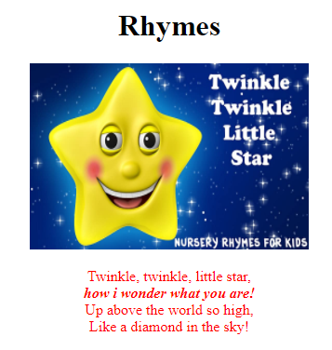

**6 . Design and create webpage for your wish list[What you want to do]. Also list challenges and opportunities along with images to present your dreams [List ordered and un-ordered ,image ,table]**

<!DOCTYPE HTML>

<body bgcolor="cyan">

<h2> Illustration of Wish list </h2>

<table border="11">

<tr style= "color:blue">

<th> Wish </th>

<th> Image of Wish </th>

<th> Features </th>

</tr>

<tr>

<td> To buy a new Iphone 12Pro </td>

<td><img src="iphone 12 pro.jpg" width="390" height="250"></IMG></td>

<td><ul type="square">

<li>Iphone 12 </li>

<li>Brand :Apple</li>

<li>Operating system :iOS</li>

<li>Screen size : 6.1 inches screen</li>

<li> Front camera resolution: 12 MP Front Camera</li>

<li>Wireless Charging With Fast Charging </li>

<li>Storage capacity 128 GB</li></td>

</tr>

<tr>

<td> To buy a Luxurious Villa </td>

<td><img src="villa.jpg" width="390" height="250"></td>

<td>

<ol type=1>

<li>Excellent Staff and Services.</li>

<li> Superb Design.</li>

<li> Central Location.</li>

<li>Good Maintenance.</li>

<li>swimming pool</li>

<li>indoor games</li>

</td>

</tr>

</table>

</body>

</html>

**Output:**

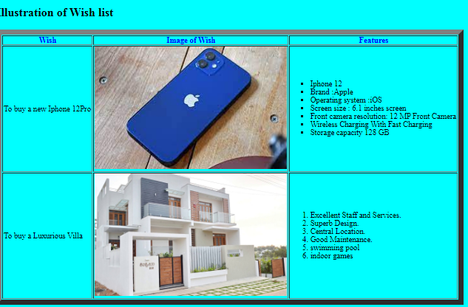

**7. Design and create webpage using HTML and CSS about an awesome animal (Use necessary CSS tags)**

<!DOCTYPE html>

<style>

p

{

font-style:italic;

color:white;

background-color:green;

text-align:center;

}

h1

{

background-color:orange ;

}

body

{

background-color:lightblue;

font-style:bold;

font-size:18px;

color:red;

}

</style>

<body>

<center>

<h1>My Favourite Animal</h1>

<img src="tiger.jpg" width="200" height=”200”></img>

<p> The tiger is the largest cat .<br>

It is our National Animal.<br>

It eat other animals like deer. </p></center>

<ol type="1">

<li>Lifespan: 10 – 15 years </li>

<li>Speed: 49 – 65 km/h</li>

<li>Height: 70 – 120 cm </li>

<li>weight: 90 – 310 kg (Adult)</li>

<li>Diet: Carnivore</li>

</ol>

</center>

</body>

</html>

**Output:**

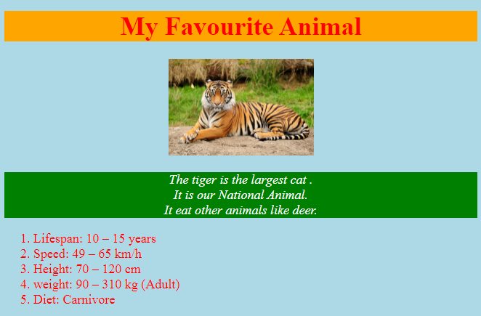

**8. Design and create web page for a travel book/recipe book with more than 3 pages, table to list places/recipes.**

<!DOCTYPE html>

<body>

<center><font size="20" color="red"><i> Illustration of Heritage places in Mysuru </font><br><br><br>

<iframe src="mysuru.html" width="300" height="300" name="iframe1" border =4> Home </iframe></center>

</body>

<table border="4" align="center">

<tr>

<td><b> List of places <b><br><br>

<a href="chamundi.html" target="iframe1"> Click here to Chamundi Hill</a><br><br>

<a href="GRS.html" target="iframe1"> Click here to View Wonderful GRS Amusement Park</a><br><br>

<a href="zoo.html" target="iframe1"> Click here to View Mysuru Zoo</a><br><br>

<a href="krs.html" target="iframe1"> Click here to View Brindavan Garden</a><br>

</td>

<tr>

</table>

</html>

Mysuru.html

<html>

<body>

<img src="mysuru.jpg" height=300 width="300">

</body>

</html>

chamundi.html

<html>

<body>

<img src="mysuru.jpg" height=300 width="300">

</body>

</html>

Output:

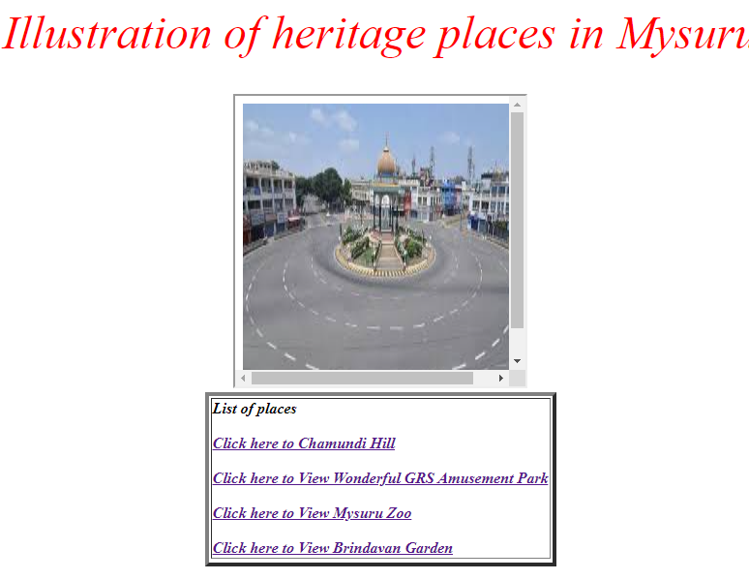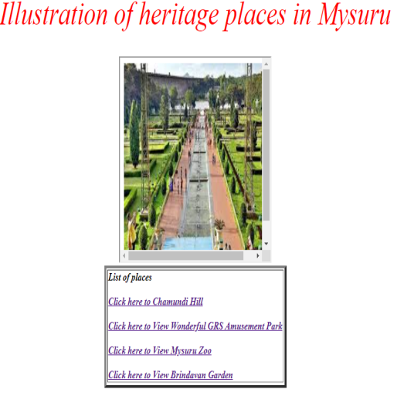

**9. Design and create web page with JavaScript to design a simple calculator to perform the following operations: sum, product, difference and quotient**

<!doctype html>

<body>

<script>

function add()

{

var a,b,c;

a=Number(document.getElementById("first").value);

b=Number(document.getElementById("second").value);

c= a + b;

document.getElementById("answer").value=c;

}

function sub()

{

var a,b,c;

a=Number(document.getElementById("first").value);

b=Number(document.getElementById("second").value);

c= a - b;

document.getElementById("answer").value=c;

}

function mul()

{

var a,b,c;

a=Number(document.getElementById("first").value);

b=Number(document.getElementById("second").value);

c= a \* b;

document.getElementById("answer").value=c;

}

function div()

{

var a,b,c;

a=Number(document.getElementById("first").value);

b=Number(document.getElementById("second").value);

c= a / b;

document.getElementById("answer").value=c;

}

</script>

<body>

Enter the First number : <input type="text" id="first"><br>

Enter the Second number: <input type="text" id="second"><br>

<button onclick="add()">ADD</button>

<button onclick="sub()">sub</button>

<button onclick="mul()">Mul</button>

<button onclick="div()">div</button> <br>

ANSWER : <input type="text" id="answer">

</body>

</html>

**Output:**

**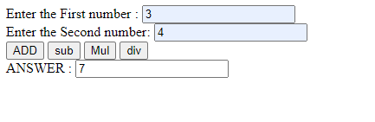**

**\**

**10.** **Design and create a personal webpage with dashboard**

Step 1: In Google search for wordpress

Step 2: Login to your google account

Step 3 : Select the Domain name for the website

Step 4 : Enter the name for the website

Step 5: Click on write button on top right corner

Step 6: Select the grid layout

Step 8: Add Heading, Paragraph, Images, Background Color for all pages

Step 9: Preview the website & Publish.

**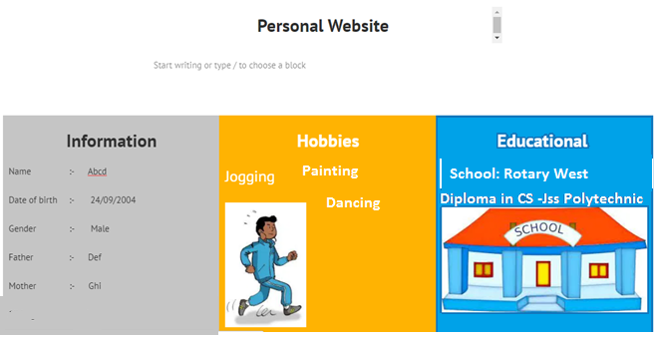**

**11. Design and create web page about advantages of business process automation with respect to your branch of engineering**

<!DOCTYPE html>

<head>

<title>B P A </title>

</head>

<body bgcolor="pink">

<h1><marquee>Business Process Automation</marquee></h1><hr>

<p align="center">It is the use of technology to execute repetitive processes in a business where manual effort can be replaced</p>

<img src="p1.jpg">

<font color="red">

<h2> Benefits of BPA </h2>

<ol type="a">

<li>Better allocation of the workforce</li>

<li>Cost reduction</li>

<li>Better collaboration</li>

<li>Makes your organization more efficient.</li>

<li>Deeper insights into the business process.</li>

</ol>

</body>

</html>

Output:

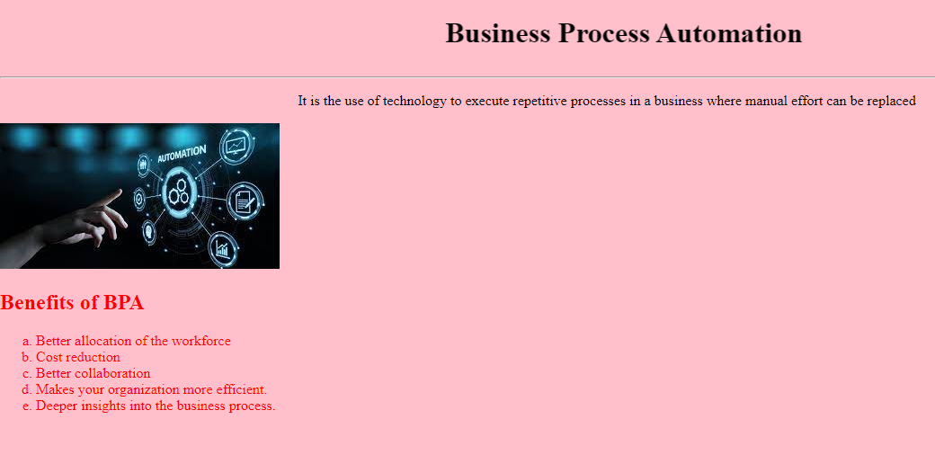

**12. Create a workflow for education loan approval in bank/diploma admission process (Use any tool)**

**Bank Loan Approval**

Step1: In Google search trello.com

Step 2:login to Trello using your gmail.

Step 3: give team name (“diploma admission process”) and select team type

Step 4: click on “create new board”

Step 5: Give a board name select the board visibility from the dropdown.

Step 6: create lists by clicking on add list button.

Step 7: Add one or more labels for every card

* Green color🡪All good & accepted
* Yellow & purple color🡪under process
* Red color🡪rejected

Step 8: Change background image, add stickers From Menu

**Output : Diploma Admission process**

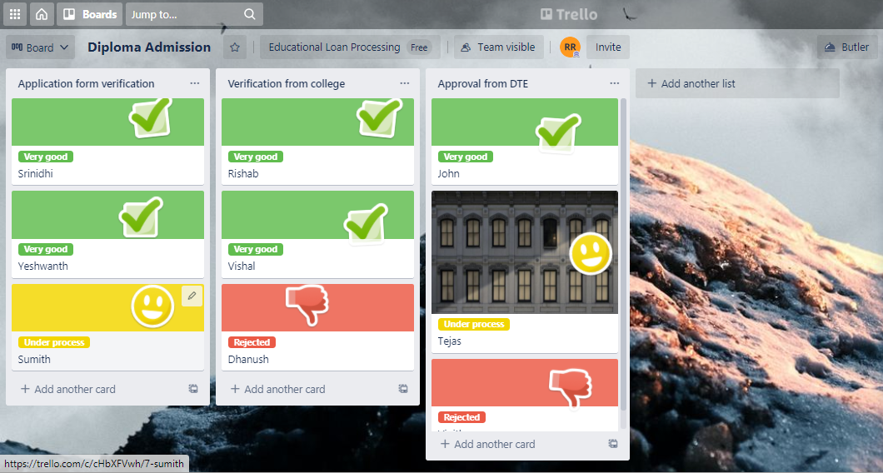

**Output : Education Loan Approval In Bank**

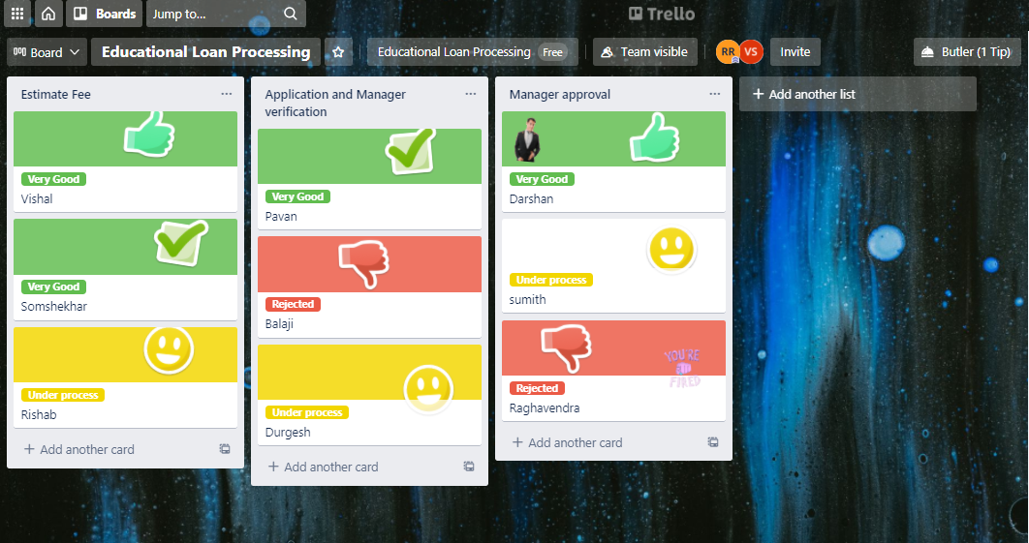

Step 1: In google search , draw.io

Step 2: Select flowchart and draw

Step 3: Save as .html format

1. **Diploma Admission process**

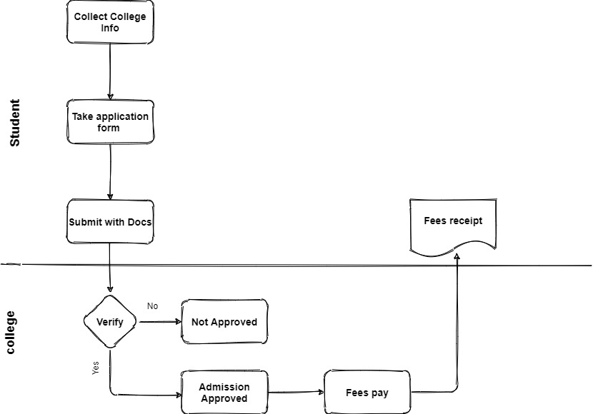

**b. Education Loan Approval In Bank**

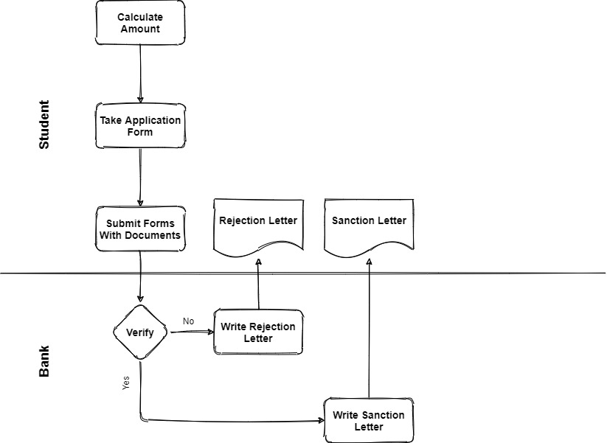

**13. Create user account and demonstrate use of Google drive, Google docs, Google Co-lab (Usage of Jupyter Notebook)**

**a)Google drive**

Step 1: Login to gmail go to  [drive.google.com](https://drive.google.com/" \t "_blank).

Step 2: At the top left, click **New** 🡪  **File Upload**or**Folder Upload.**

Step 3: Choose the file or folder you want to upload.

**b)Google Docs**

**S**tep 1: Login to gmail. Go to docs

**S**tep 2: Select Resume

Step 3: Select any resume template

Step 4: Fill up your details

c**)Google Co-lab**

**i. Program to add,subtract,multiply and divide 2 munbers**

a=10

b=20

sum=a + b

diff=a - b

quo=b / a

pro=a \* b

print(“ The sum is “ , sum)

print(“ The difference is “ , diff)

print(“ The product is “ , pro)

print(“ The quotient is “ , quo)

OUTPUT:

The sum is 30

The difference is -10

The product is 200

The quotient is 2

**ii. program to print if student has passed or failed**

marks=75

if marks >= 35:

print(“student has passed”)

else**:**

print(“student has failed”)

**OUTPUT:**

student has passed

**14. Installation of Antivirus software**

There are many antivirus products available in market like Avast, McAfee, Kaspersky , Norton etc

**Steps to install an antivirus program on your computer**

Consider Avast antivirus

Step1: type below link in your internet browser’s address bar <https://download.cnet.com/Avast-pro-antivirus/3000_2239_410181058.html>

This link redirects you to fill download page

Step 2: click on “download now” button

Step 3: wait for the yellow bar to appear and then right click and choose download the file

Step 4: click on the run and wait for the program to be downloading and run

Step 6: your installation has been completed click “OK” to close

**15. Demonstration and hands on browser settings**

**Google Chrome Browser Settings**

1. **You and Google**

**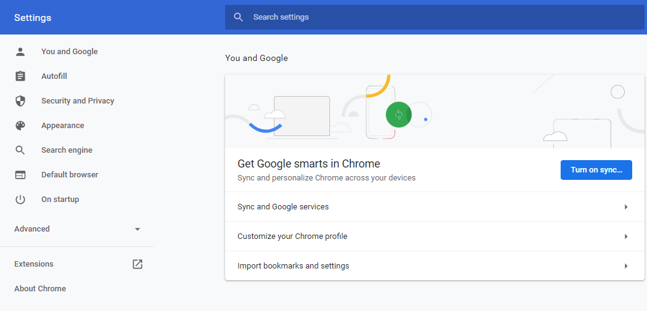**

1. **Autofill**

**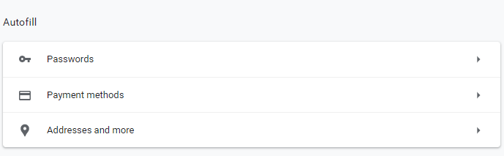**

1. **Appearance**

**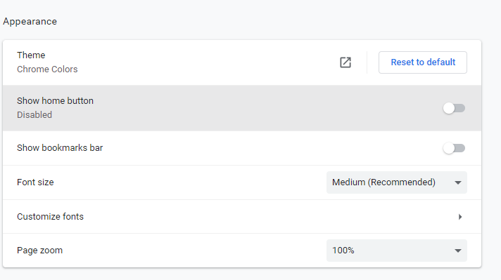**

1. **Search Engine**

**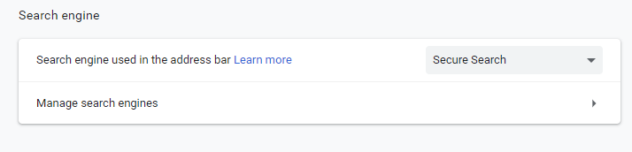**

1. **Default Browser**

**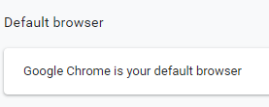**

1. **On start up**

**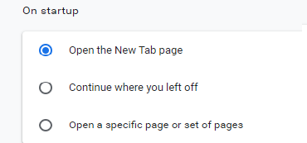**

1. **About Chrome**

**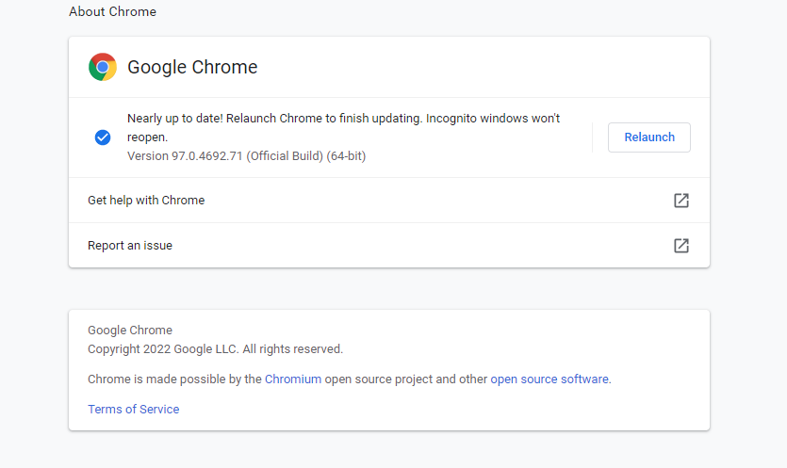**

**Program 18: Demonstration and hands on privacy settings and password policy**

1. **privacy settings of Google Chrome Browser**

**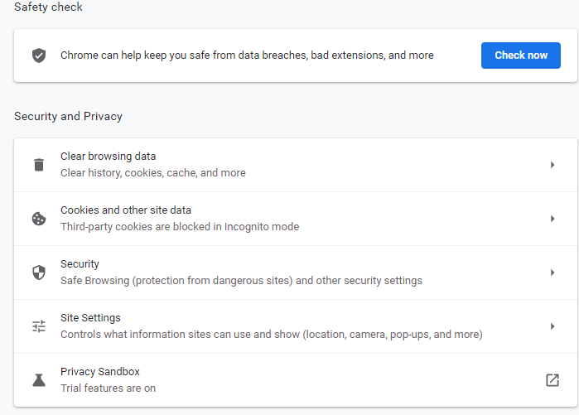**

1. **password policy**

There are many steps you can take to keep your private data secure

1. **Password-protection:** all your digital devices should be password protected for increased security.
2. **Password** **complexity and length:** Choose strong password so that it should have at least one uppercase and lowercase alphabet, one/more special character.
3. **Keep your computer virus free:** Install Antivirus & update it regularly.
4. **Secure your browser, use secured Wi-Fi connections and only use genuine soft wares**
5. **Password Update :** Change your password regularly.